

**KPLABS Course**

**AWS Certified Cloud Practitioner 2023**

**Networking Services**

## **ISSUED BY**

Zeal Vora

## **REPRESENTATIVE**

[instructors@kplabs.in](mailto:instructors@kplabs.in)

# 

# **Section - Networking Services**

## **Module 1: Domain Name System (DNS)**

DNS converts Domain Name to IP Address. For example:

google.com ⇒ 216.58.216.78

facebook.com ⇒ 173.252.120.6

yahoo.com ⇒ 98.139.183.24



1.2 DNS Records

DNS records are basically mapping files stored in the DNS server

Example:

kplabs.in → 128.30.45.50

ipa.kplabs.in → 128.45.32.54

spacewalk.kplabs.in → 139.20.42.52

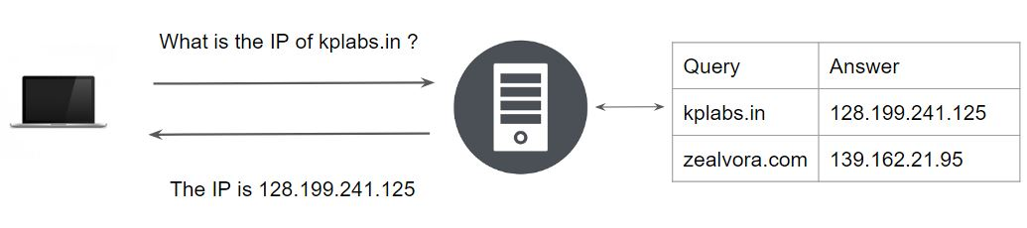

There are various types of DNS records, each one serves a specific purpose.

Types of DNS records :

* A
* AAAA
* CNAME
* ALIAS
* MX
* NS
* PTR
* SOA
* TXT
* SRV

For exams, you do not need to know in detail about each DNS record type.

## 

## 

## **Module 2: AWS Route53**

2.1 Overview of DNS Server

In order to get the DNS resolution, it is important to have a DNS Server running.

There are various softwares like Bind that provides features associated with DNS Resolutions.

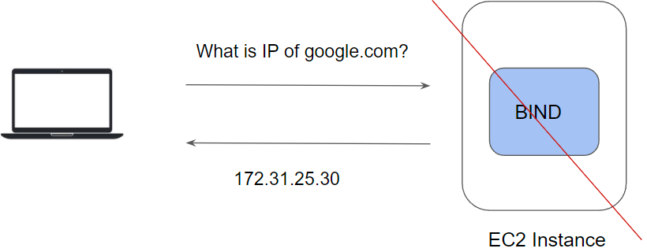

2.2 Managed vs Unmanaged

Un-Managed Approach :

* Organizations can configure and maintain their own DNS servers.
* Good for learning, not recommended in the longer term.

Managed Approach:

* Let the service provider manage the DNS Servers for you.
* Sleep peacefully.

Managed DNS Service

Amazon Route 53 is a highly available and scalable cloud Domain Name System (DNS) web service.

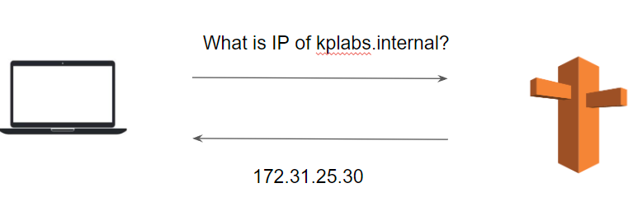

Overview of Route53

AWS Route53 is a managed cloud DNS service on the cloud.

Apart from standard DNS functionality, it provides a great set of features like:

* Launching private hosted zones.
* Health Checks & Monitoring.
* Routing capabilities.
* Geo DNS
* DNS Failover and many more

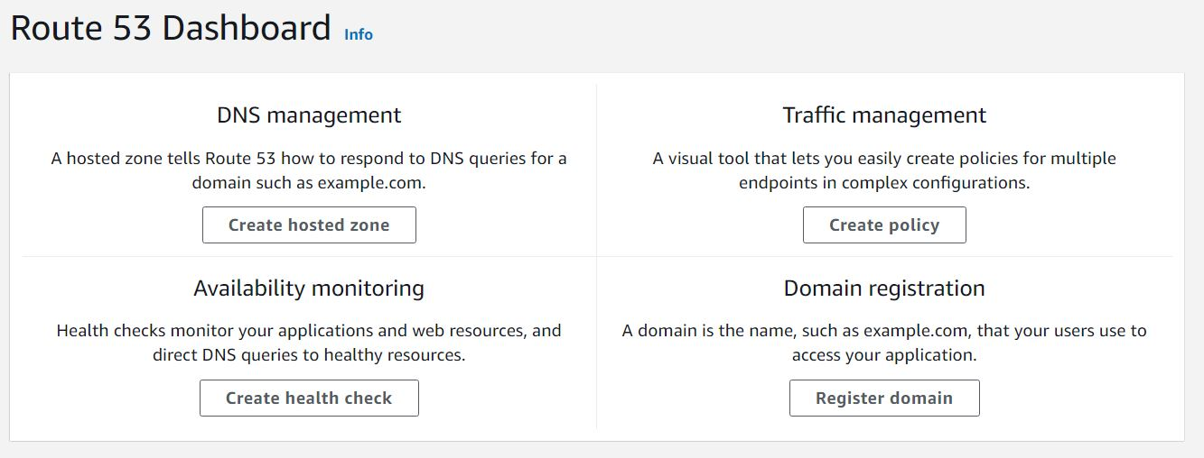

## 

## 

## **Module 3: Content Delivery Networks**

Content Delivery Networks act as a reverse proxy at a higher level. The primary benefits of CDN’s are that they have data centers across the globe and can perform important activities including Caching, protecting origin servers against attacks, and others.

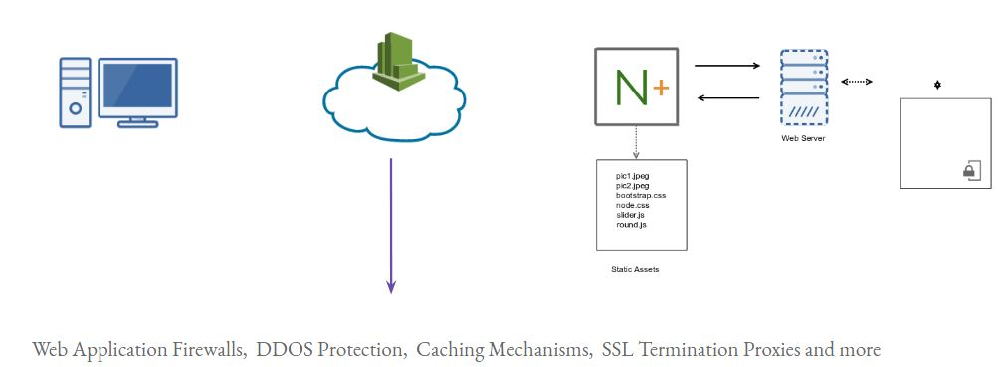

3.1 Edge Locations

An edge location is where end-users access services located at AWS.

They are located in most of the major cities around the world and are specifically used by CloudFront (CDN) to distribute content to end-users to reduce latency.

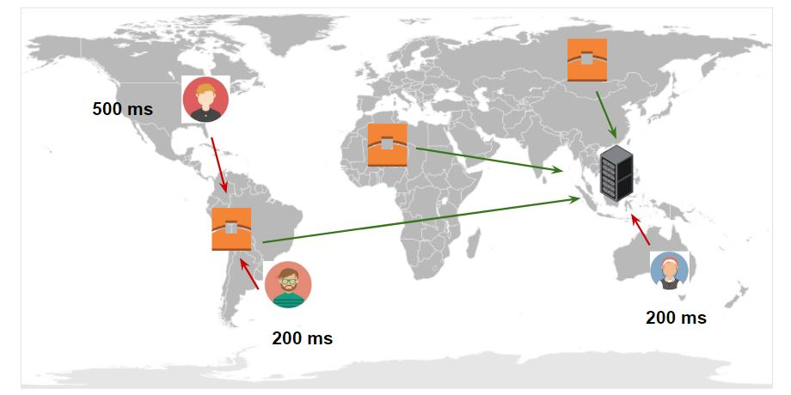

3.2 AWS CloudFront

AWS CloudFront is a CDN service offered by AWS.

High-Level steps involved in creating CloudFront distribution with a simple web-page:

1. Create a server with sample HTML Website
2. Create CloudFront Distribution
3. Load the website from CloudFront
4. Explore various features of CloudFront

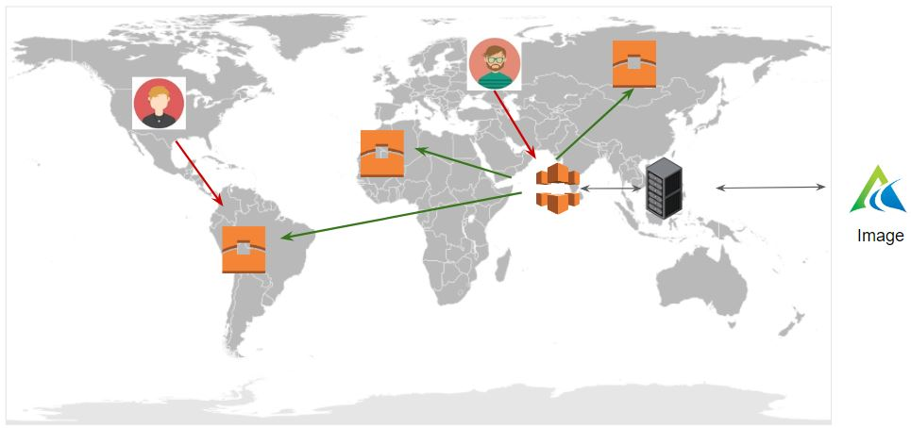

## 

## **Module 4: Amazon Workspace**

Amazon Workspaces is a managed, secure cloud desktop service.

Users can access the workspace from various clients like Chromebook, iPad, MAC, Windows and others.

We pay on the monthly or hourly basis for the workspace that we create.

## 

## **Module 5: Disaster Recovery Technique**

There can be various disaster recovery designs that we can implement, this directly depends on how quickly we want to recover from a disaster, in short RTO and RPO.

Broadly classified into 4 types :

i) Backup & Restore

ii) Pilot Light

iii) Warm Standby

iv) Multi-Site

Scenerio 1 - Backup & Restore

Based on a simple/cost-effective method which requires us to constantly take a backup of our data and store it to service like S3 and restore when disaster strikes.

For an on-premise server with a huge amount of data types in tens of terabytes, then can use technology like direct connect or import/export to back up their data to AWS.



Scenario 2 - Pilot Light

Minimal version of the server in the stopped state or AMI present.

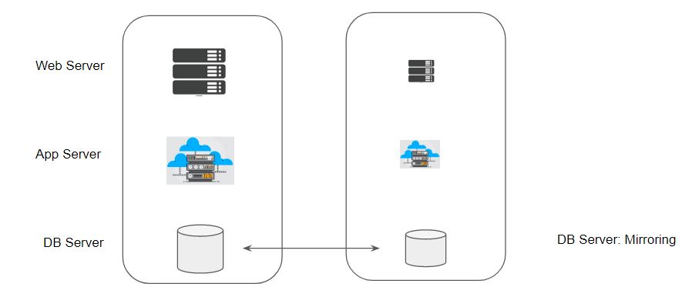

Scenario 3 - Warm Standby

* The server runs with minimal sizes.
* When a disaster happens, the server is scaled up for production.

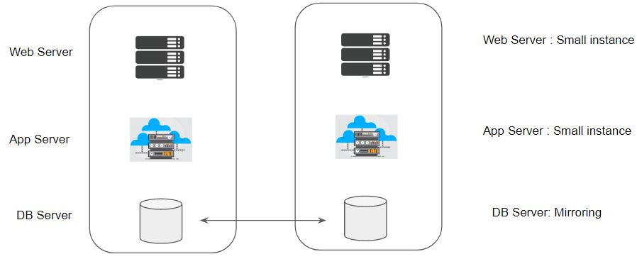

Scenario 4 - Multi-Site

Complete 1 to 1 mirror of your production environment.

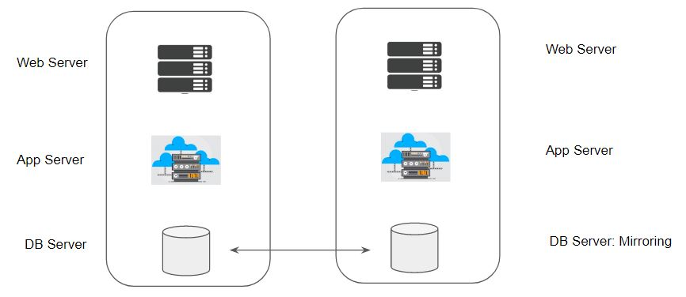

## **Module 6: AWS Global Accelerator**

AWS Global Accelerator is a service that improves the availability and performance of your applications with local or global users.

It provides static IP addresses that act as a fixed entry point to your application endpoints in a single or multiple AWS Region

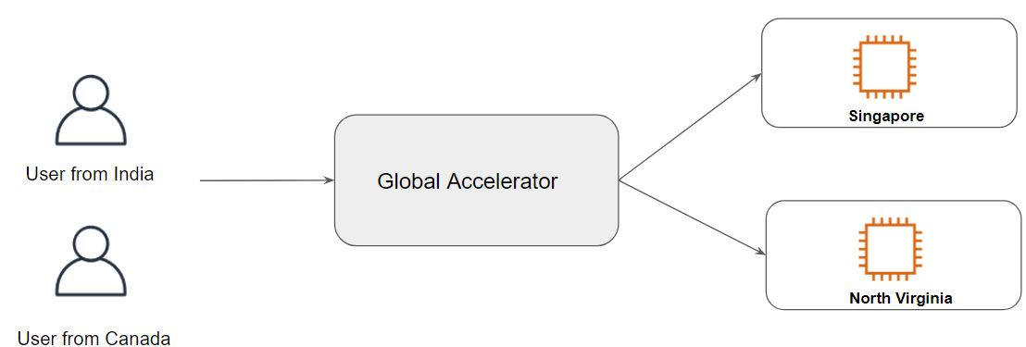

Following is the simplified diagrammatic difference:

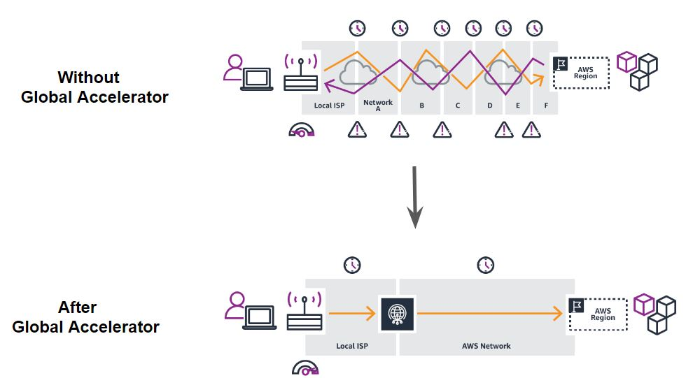

The high-level working of AWS Global Accelerator can be seen in the following diagram:

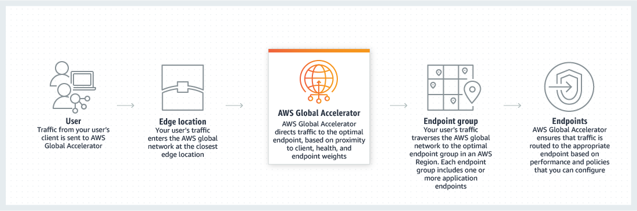

## **Join Our Discord Community**

We invite you to join our Discord community, where you can interact with our support team for any course-based technical queries and connect with other students who are doing the same course.

Joining URL:

<http://kplabs.in/chat>

